To Encrypt user credntials and using them in UIPath Automation Script,follow below steps:

- Open Credential Manager from Start Menu:
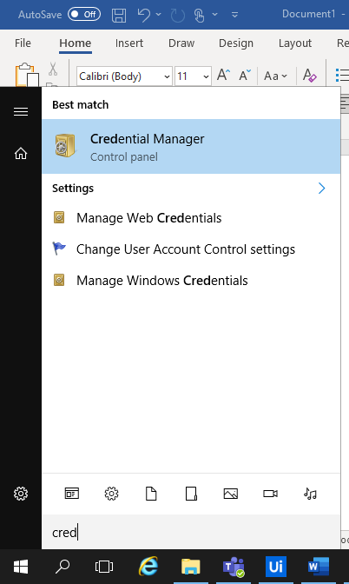

- Select Windows Credentials under ‘Manage your credentials’ section:

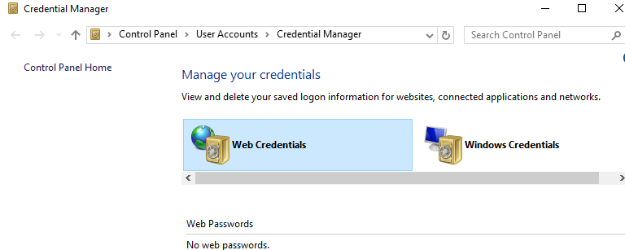

- Below options will be displayed:

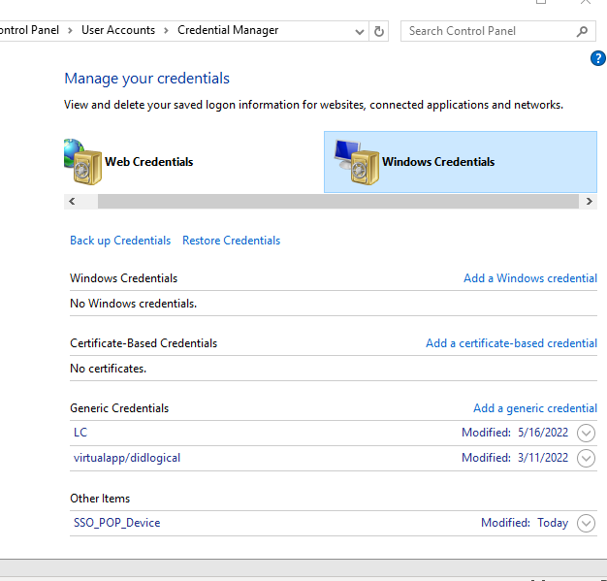

- Click on the ‘Add a generic credential’ as highlighted above, below window will be populated for inputs:

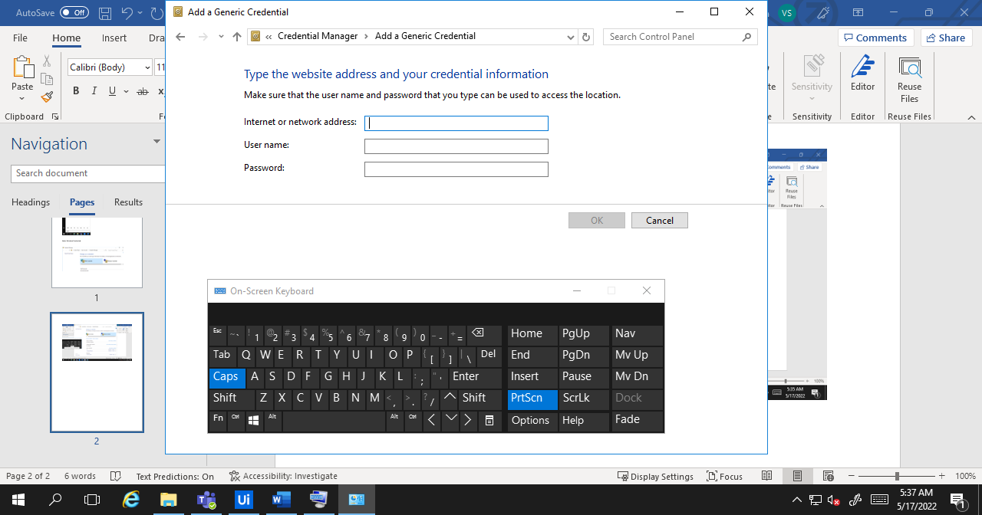

- Provide the name of the Application, username and password in the input text areas.
Click on OK button

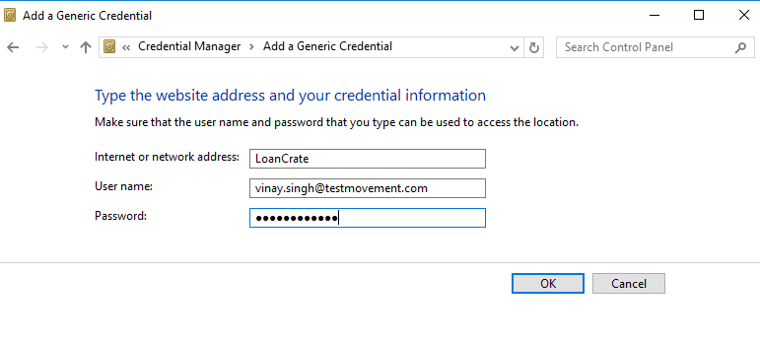

- Credentials will be added under the Generic Credentials section with the application name.

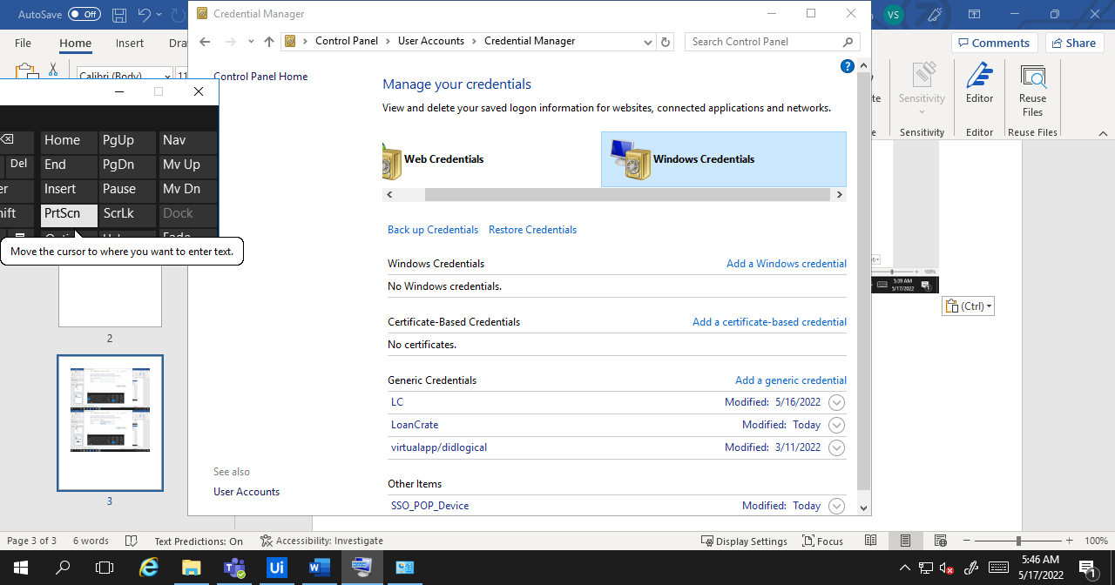

- Open UiPath application and add “Uipath.Credentials.Activities” package by clicking on the Manage Package button as highlighted below

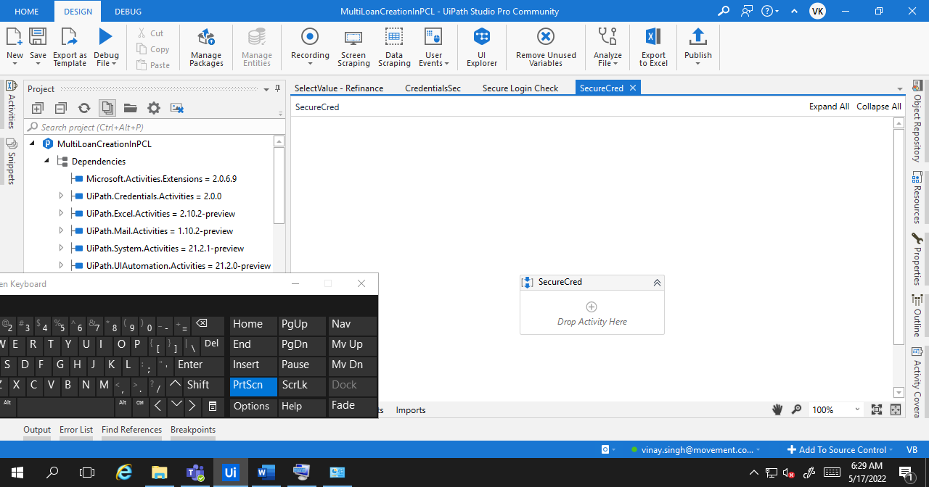

- Search for “UiPath.Credentials.Activities” under All Packages and click on the displayed result.
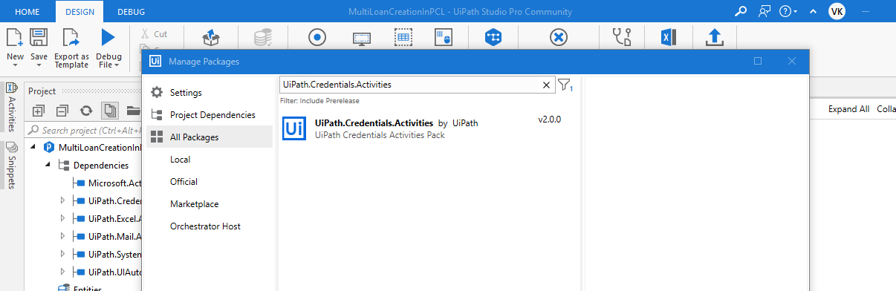

- Install the package and Click on Cancel button to close the window:

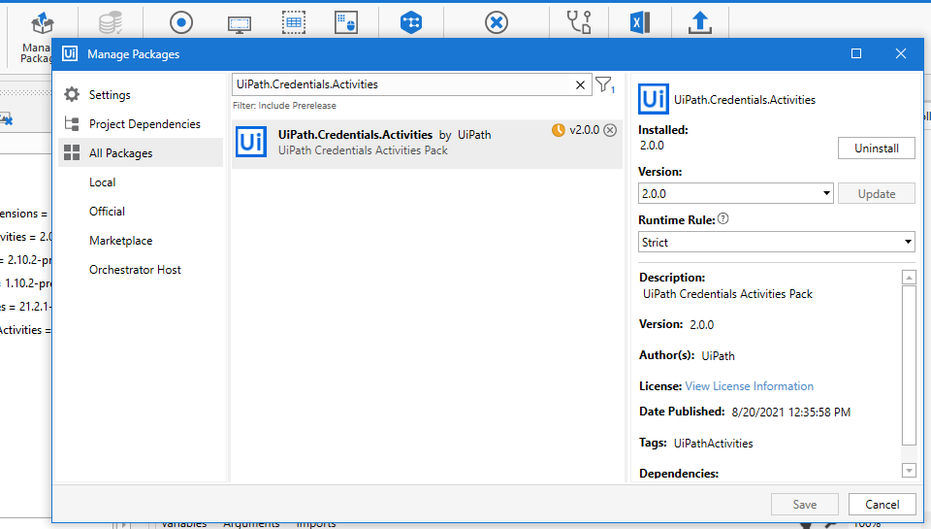

- Add a new Activity ‘Get Secure Credentials’ and open its Property tab.

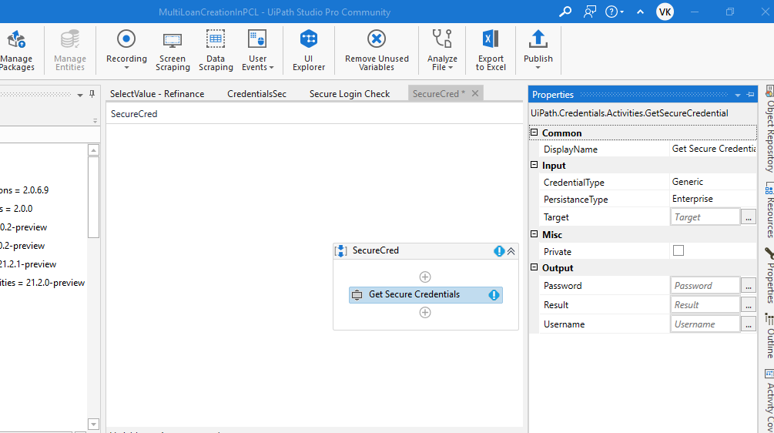

- Add application name value i.e. LoanCrate (added in Step 5) in Target input.
Create variables for Password and Username (It will fetch data from the Generic Credentials):

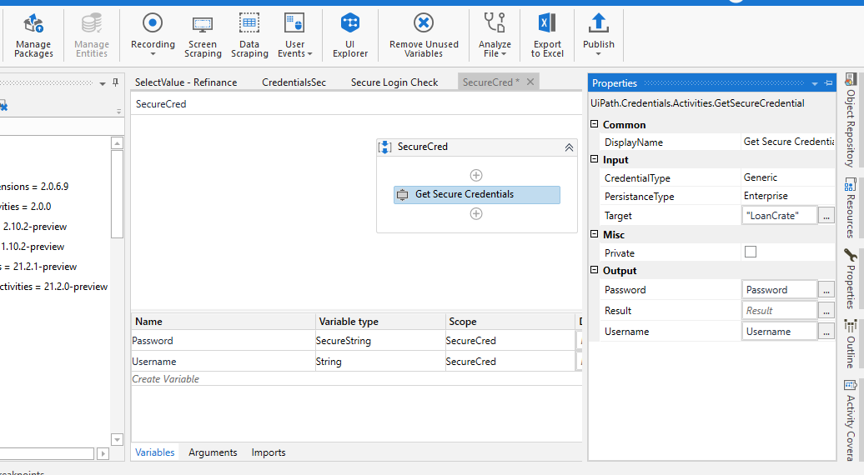

- Use ‘Type Into’ Activity to add username by using UserName variable as created above.
- Use ‘Type Secure Text’ Activity to add password by adding ‘Password’ variable in SecureText of Property section.

